A driver that was made for running on Windows OS cannot be used on Linux OS because they have a different “Driver Architecture”.

Windows Driver Model (WDM) Architecture:

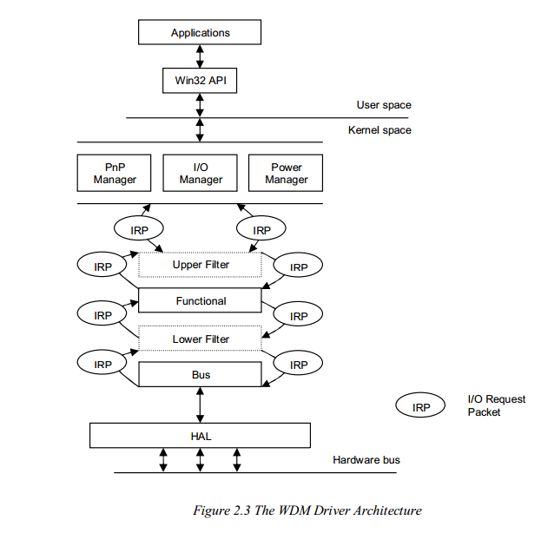

Linux Driver Architecture:

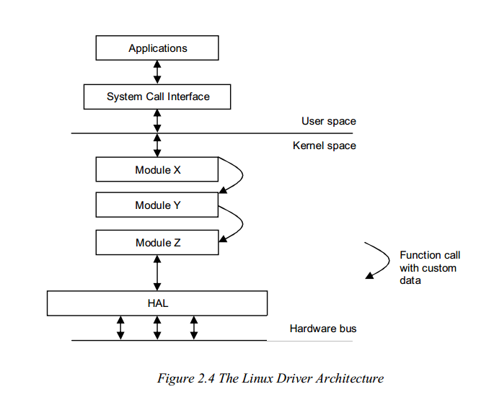

References:

<http://www.cs.ru.ac.za/research/g98t4414/static/papers/oscomposr.pdf>